**CoSeT: The Guide**

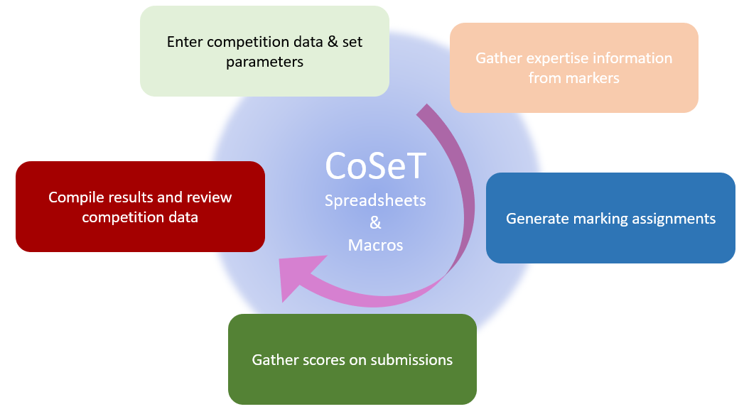

**Bert van den Berg**

**March 2021**

# Overview

CoSeT is software tool for Competitive Selection processes. These selection processes involve experts providing scores on submissions, which are subsequently combined to arrive at ranked lists of submissions. CoSeT focuses on managing the information about the competition, and provides functions for assigning experts to submissions, and compiling the scores received from the experts.

CoSeT is implemented as an Excel workbook with sheets and macros. The workbook provides tables for information about selection criteria, submissions, markers, marking assignments, scoring and comments. The macros create the tables used, assemble marker assignment tables, create marker scoresheets, and compile the markers’ scores. CoSeT can be used with a variety of information management approaches (e.g., shared online sheets, online-forms or extranets). It also offers flexibility in how markers are assigned to submissions, and how their scores are converted into rank-ordered lists of submissions.

For a discussion of the concepts associated with competitive selection processes see [Concepts and Best Practices in Competitive Selection Processes](https://github.com/Bert610/CoSeT/raw/main/Concepts%20and%20Best%20Practices%20in%20Competitive%20Selection%20Processes.pdf).

Contents

Overview 2

List of Figures 4

Introduction to CoSeT 5

Using CoSeT in Selection Competitions 5

Design the Competition 6

Define how Information will be Shared with the Marking Experts 6

Identify the Expertise of the Markers Who Will be Providing Scores 7

Assign Experts to Score Submissions 9

Share the Submissions and Scoresheets with the Experts 10

Compile the Scores to Produce a Ranked List of Submissions 11

Compile the Comments to Provide Feedback on the Submissions 12

Analyze the Results of the Competition 13

Other Information about CoSeT 14

On Exclusions 14

Assignment Methods supported by CoSeT 14

The Marker Assignment 16

On Designing the Selection Competition 16

On Dealing with Did-Not-Submit and Other Dropouts 17

On Using Expertise to Implement Sub-groups of Submissions and/or Markers 17

Normalized Scoring 19

Data Management 19

Workflows Enabled by CoSeT 20

Workflow #1: Online Worksheets and Expertise Gathered via Project Expertise 20

Workflow #2: Personalized Worksheets and Expertise Gathered via Keyword Ratings 22

The Macros 26

Worksheets in CoSeT 28

Manual Edits 29

For Further Information 29

Appendix A: Tables and Documents Created by CoSeT 30

Appendix B: System Parameters Sheet 32

Appendix C: Competition Parameters Sheet 33

Appendix D: Using CoSeT for Clustered Competitions 35

# 

# List of Figures

Figure 1: Example Project Expertise Sheet 7

Figure 2: Example Project X Marker table 8

Figure 3: Extract from Assignments Master sheet 9

Figure 4: Extract from Expertise Crosswalk Sheet 10

Figure 5: Extract of Results sheet (for online score sheets) 11

Figure 6: Sample Single Page Marker Scoresheet 12

Figure 7: Extract of Rank-ordered Projects (random data) 13

Figure 8: Example of the Analysis sheet (random data) 14

Figure 9: Example of Analysis Chart (random data) 15

Figure 10: Sample CoSeT Marker Expertise on Projects 16

Figure 11: Project X Marker table created using Keyword information 25

Figure 12: Example Scores and Comments sheet 26

Figure 13: CoSeT’s macro workflow 27

# Introduction to CoSeT

Competitive Selection processes are used to award funding, select the winners of hackathons, and identifying successful candidates in staffing processes. The steps in these competitions include:

* design and launch the competition,
* collect submissions[1] and find experts[2] to score submissions,
* Allocate the scoring of submissions to experts, and
* compile the scores and review the competition results.

CoSeT is a set of tools that makes it easier to implement selection competitions. It:

* Stores information about the criteria, submissions, and markers,
* Generates tables for collecting expertise information to link experts to submissions,
* Creates marking assignments for experts based on the expertise information,
* Generates the scoresheets, as well as worksheets for collecting markers comments,
* Compiles the scores from experts to show the final rank-ordered list,
* Creates analysis data that can help understand the quality of the selection process, and
* Compiles the comments for further processing.

CoSeT is implemented as an Excel workbook with macros. It is available on GitHub under an MIT license. If you are interested in learning more about the general concepts of Competitive Selection processes, refer to the companion document “[Concepts and Best Practices in Competitive Selection Processes](https://github.com/Bert610/CoSeT/raw/main/Concepts%20and%20Best%20Practices%20in%20Competitive%20Selection%20Processes.pdf)”.

This document aims to provide insight into the methods supported by CoSeT. It also describes how to use CoSeT with various competition workflows. It also provides an overview of the sheets and macros in CoSeT.

# Using CoSeT in Selection Competitions

The next sections of this document follow the typical process for running a competitive selection process with CoSeT. These steps are:

* Design the competition.
* Define how information will be shared with the marking experts.
* Identify the expertise of the experts who will be providing scores.
* Assign experts to mark submissions.
* Share the submissions and scoresheets with the experts.
* Compile the scores to produce a ranked list of submissions.
* Compile the comments to provide feedback on the submissions.
* Analyze the results of the competition.

## Design the Competition

People who will be implementing a selection competition need to consider how many submissions are expected, how many evaluation criteria should be used (and with what scoring allocation), how many experts will be involved in the scoring, and how will the expertise of the markers be identified (or not).

CoSeT has separate tables for this information as shown in Table 1 below.

|  |  |
| --- | --- |
| **Table** | **Minimum Information Required in CoSeT** |
| Projects | Project name or title |
| Markers | Name and email |
| Criteria | Name, minimum and maximum score limits |
| Keywords | Name, weight |

Table : Key Tables for Competition Inputs

In addition to these tables of information, the competition designers will also need to decide:

* How many experts should be scoring each submission?
* How many submissions each expert should be asked to evaluate?
* Whether the experts will asked to provide comments (to be shared with the applicants)?

The parameters for these choices are presented in CoSeT’s Competition Parameters sheet for organizers to specify. Once the data has been input and the competition parameters set, the competition organizer creates a Competition Workbook (using a CoSeT macro).

## Define how Information will be Shared with the Marking Experts

It is important that the relevant information for the competition can be shared with experts in a fashion that is convenient, reliable, and secure. Modern approaches include secure extranets, and shared online documents. Email may also be considered.

If online shared documents are planned, CoSeT’s tables can be adapted for use in the online sheets. This includes the tables for[3]: collecting the markers’ anticipated expertise (either directly on each project or indirectly based on keywords), assigning submissions for markers to score, compiling the scores to determine the final ranked list of submissions.

If secure extranets or email is planned, CoSeT will generate documents customized for sharing with the experts. CoSeT creates separate Excel files to gather marker expertise information, and other Excel files to gather their scores and comments on submissions. CoSeT will also compile information from these files when returned by the markers.

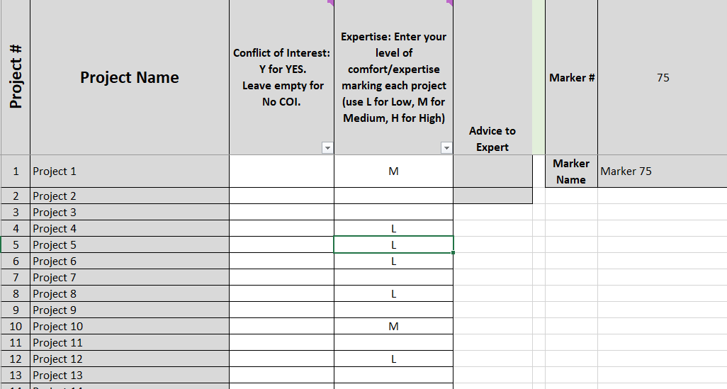

Figure : Example Project Expertise Sheet

See Appendix A for examples of the tables and documents created by CoSeT.

## Identify the Expertise of the Markers Who Will be Providing Scores

The key resource for selection competitions are the experts who will be evaluating the submissions. Once these experts are identified, it is important to establish how their expertise aligns with the (expected) submissions – this step is a precursor to making marking assignments for the experts.

Several approaches are possible:

* the competition organizers can attempt to build expertise profiles for the experts from available information, or
* the experts can be asked to rate their confidence on keywords associated with the competition, or
* the experts can be asked to rate their expertise based on brief summaries of the (expected) submissions.

CoSeT supports each of these approaches with tables and macros. The result is a table of marker confidence levels for the submissions, rated as High, Medium, Low or eXcluded. This expertise table (Project X Marker table) may also include blank entries, enabling assignments to only be made to markers with declared expertise for a project[4].

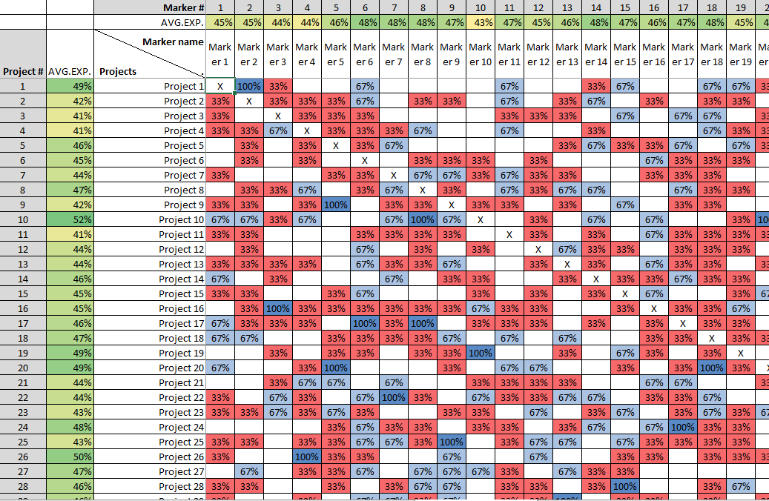

Figure : Example Project X Marker table

If the competition organizers will be defining the expertise of the experts against the submissions, this can be entered directly in the Project X Marker table. This approach is laborious for the organizers to do thoroughly but does enable assignments to be made if little is known about the markers’ expertise.

CoSeT includes a table for compiling the markers’ expertise against the competition’s keywords (Keyword Expertise). This can be completed by the organizers, filled in by the experts via an online shared sheet, or compiled by CoSeT from Keyword Expertise sheets sent to the experts.

CoSeT also includes a table for compiling the markers’ confidence in marking the submissions (Project Expertise). This sheet can also be completed by the organizers, filled in by the experts via an online shared sheet, or compiled from the Project Expertise sheets sent to the experts.

## Assign Experts to Score Submissions

In larger competitions, there can be hundreds or thousands of submissions, and many hundreds of markers. Even when there are a few dozen submissions it can be laborious and error prone to assign markers to submissions. CoSeT does this quickly, while allowing manual control over key assignments.

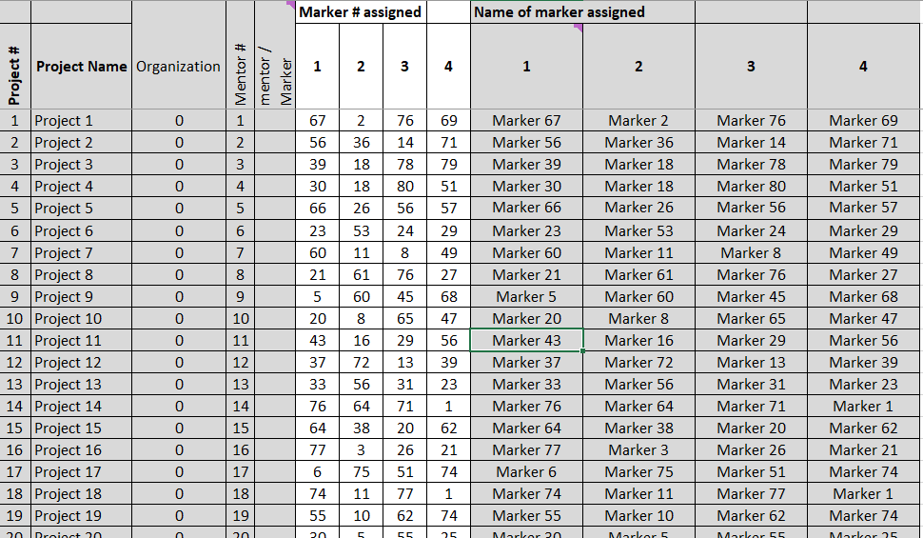

Figure : Extract from Assignments Master sheet

CoSeT’s assignment process starts with the table of Project X Marker expertise[5], as well as any mentoring exclusions signaled on the Projects sheet. CoSeT reads the information specified, and creates assignments based on the following:

* Make assignments based on rounds (each submission gets one marker assigned in the first round, then each submission is assigned a second marker in the second round, etc.)[6].
* For each round of assignments, start with the submission with the lowest available expertise and assign to it the marker with the highest available expertise.

The approach attempts to give each submission a comparable level of expertise in the assigned markers. Limits to assignments include any exclusions specified and limits on the number of assignments per marker.

Once CoSeT has applied the above algorithm to define marking assignments, it then looks to fill in any assignment gaps by swapping markers of similar expertise.

CoSeT’s assignment results are displayed on two worksheets:

* The Expertise Crosswalk sheet shows the assignments, and the confidence rating for a marker on their assigned submission (see the figure below). It is also where assignments can edited.
* The Assignments Master sheet shows who is assigned to each project, and a summary of the assignments for each marker.

When the macro runs, CoSeT’s Assign Markers macro first loads the existing set of marking assignments from the Expertise Crosswalk sheet, and then works to fill in empty assignment slots.

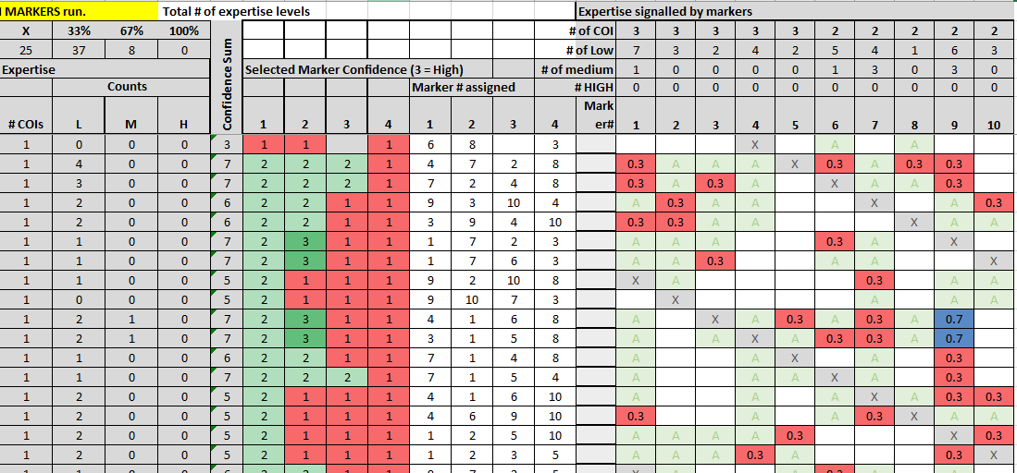

Figure : Extract from Expertise Crosswalk Sheet

## Share the Submissions and Scoresheets with the Experts

Depending on the process choices made by the competition organizers, the information may be shared with markers via shared online documents (i.e., google sheets and google forms), or by documents (Excel files) shared via a secure website or email.

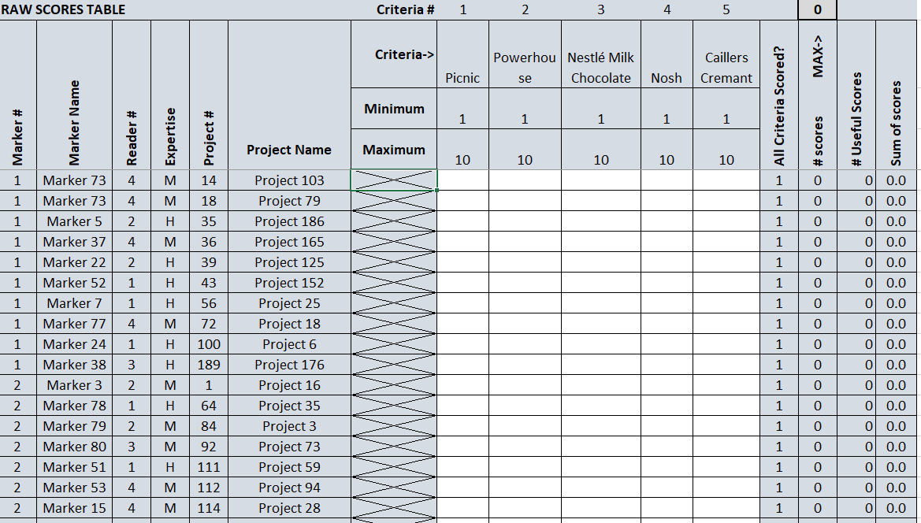

Figure : Extract of Results sheet (for online score sheets)

As noted above, CoSeT generates tables that can adapted for online sheets or online forms. It also generates the Excel workbooks for gathering information from the markers[7].

## Compile the Scores to Produce a Ranked List of Submissions

Each marker has a personalized set of marking assignments to score (and potentially to provide comments on) as shown in the table below.

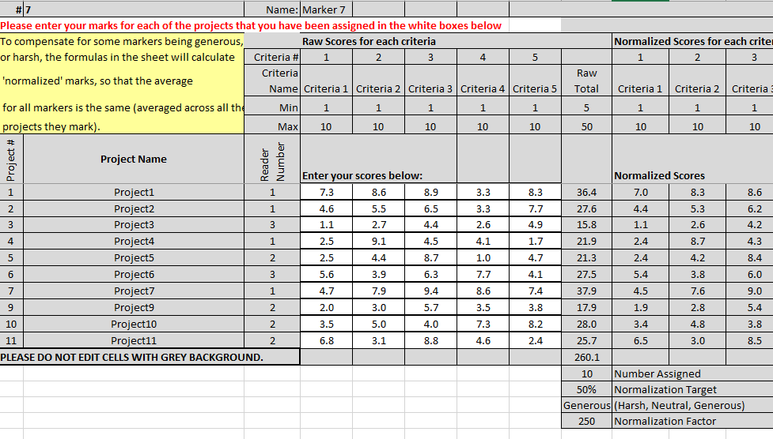

Figure : Sample Single Page Marker Scoresheet

The scores[8] from markers need to be compiled for each submission, and the submission scores need to be compiled to provide the final submission scores as a rank-ordered list (per the table below).

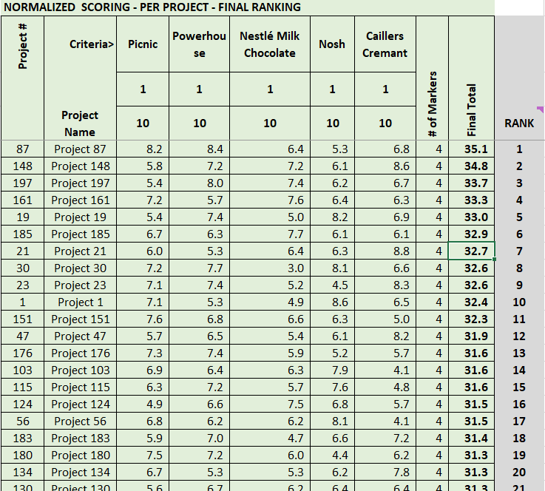

Figure : Extract of Rank-ordered Projects (random data)

CoSeT provides a scoresheet for compiling project results from online marker submissions, and a macro for loading marker scores into this Results sheet. The Results sheet uses several tables to transform the raw scores provided by markers into a list of normalized project scores.

## Compile the Comments to Provide Feedback on the Submissions

For applicants, a selection competition can be opaque. They value receiving feedback from the experts who scored their submission, both to understand why it failed or succeeded in the competition, and how they might improve future submissions.

When comments from the markers are indicated, CoSeT creates a workbook for each marker with a scoresheet for each project. The marker provides scores and comments for each criterion, as well as any overall comments. CoSeT’s macro subsequently compiles the comments from markers into separate documents for each project. The comments are organized by criteria to facilitate subsequent editing by the competition organizers.

Typically, the competition organizers will need to review and edit the compiled comments: for spelling and grammar, to ensure they do not reveal the identity of the markers, and to reflect the tone and values of the organization hosting the competition.

## Analyze the Results of the Competition

The organizers have the option of looking at the competition results with, or without score normalization. To assist the organizers in understanding the quality of the competition, a variety of metrics are calculated from the competition scores. For each submission, the metrics include:

* Average score by reader #
* Overall score for each submission
* Maximum score
* Minimum score
* Scoring variance
* Estimated standard deviation, and
* Span (maximum score – minimum score)

See Figure 8 below for an example Analysis table.

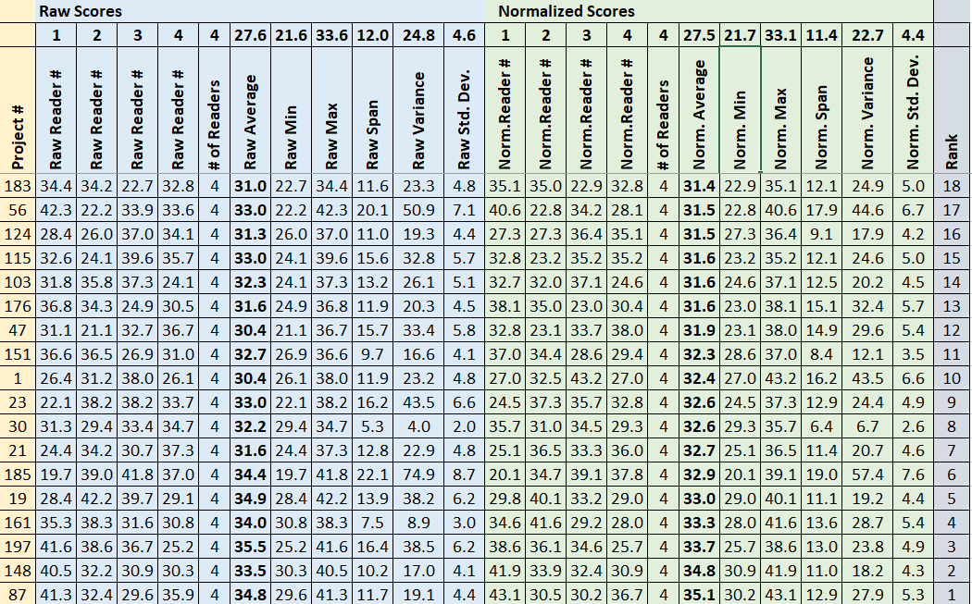

Figure : Example of the Analysis sheet (random data)

The statistics are provided both for normalized and raw scores, helping the organizers to understand whether normalization is valuable for that competition. This information is provided on the Analysis sheet, and a summary of the analysis is provided by the Analysis Chart (see Figure 9 below[9]).

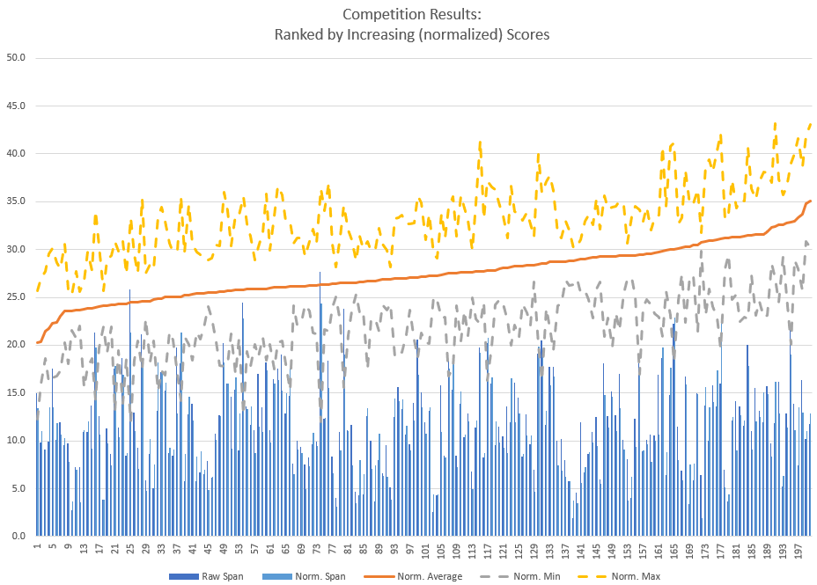

Figure : Example of Analysis Chart (random data)

# Other Information about CoSeT

The previous sections show how CoSeT can be used in typical processes in a selection competition. The following sections describe aspects of CoSeT, along with some specific techniques. This includes two example workflows.

## On Exclusions

In competitive selection processes, markers are excluded from scoring submissions for a variety of reasons that can include:

* Possible conflicts of interest (which can include many aspects)
* Past evaluation of a previous proposal
* Being a member of the same organization

CoSeT provides opportunity for the Markers to signal that they should be excluded from the review of a submission, and checks if the marker is from the same organization as the lead applicant. Organizers can signal that a marker should be excluded from evaluating a submission (by inserting an ‘X’ in the corresponding row/column of the Projects X Markers table).

## Assignment Methods supported by CoSeT

CoSeT supports both the direct and indirect method of defining the expertise used to assign scoring tasks to experts. In both cases the experts’ confidence is chunked in three buckets: L (Low), M (Medium), or H (High)[10].

Two approaches are considered to gather this expertise information.

1. **Direct method:** Markers rate their confidence in scoring each submission (L, M, or H), and signal any conflicts of interest (X). This information can be provided by completing the Project Expertise sheets or a comparable online shared sheet. CoSeT compiles these and updates the Project X Marker table. Alternatively, the competition organizers can complete a table signaling the marker expertise per project, and conflicts of interest in the Project X Marker table.
2. **Indirect method**: Staff generate a set of keywords relevant to the submissions in a competition. Markers are asked to rate their confidence in scoring as related to these keywords[11], and signal any conflicts of interest. CoSeT’s macro creates workbooks with Keyword Expertise sheets and Project Conflicts of Interest sheets.

CoSeT calculates a figure of merit for the anticipated confidence of each marker to score each submission (as the weighted scalar product of the submission’s relevance to keywords, and the expert’s confidence on the same keywords[12]). The calculated project/marker expertise table is rescaled to High (100%), Medium (66%) and Low (33%). These confidence estimates are stored in the Project X Marker table.

Both the direct and indirect method result in a table of confidence for markers about submissions. An example table of expertise from random data (10 markers on 25 projects)[13] using the Direct method is shown below:

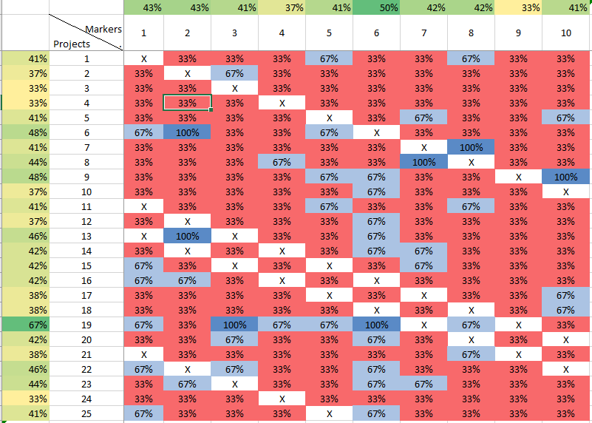

Figure : Sample CoSeT Marker Expertise on Projects

### The Marker Assignment

A more description of CoSeT’s two-step assignment algorithm follows:

* Assign markers to submissions in rounds (i.e., submissions are all assigned a first marker, then the submissions are all assigned a second marker, etc.)
  + Find the (next) submission with the lowest confidence from the available expert.
    - Find the most confident expert that is still available for this submission.
      * Make the assignment.
* A second process then looks to swap assignments, moving experts who have assignment room into existing assignments and liberating that person for the empty slot. That algorithm:
  + Finds an empty assignment slot.
  + Finds an assignment *at the same assignment round* where an available expert has the same level of expertise as the existing assignee, and the existing assignee is available for the empty slot.
  + Makes the swap.

CoSeT generally succeeds in making assignments when the number of possible marking assignments (number of markers X number of evaluations per marker) is significantly larger than the number of required assignments (number of projects X number of evaluations per project). When the number of available slots is close to the number of marking assignments required the competition organizer may need to specify a some assignments, or broaden the available expertise.

## On Designing the Selection Competition

The competition organizers have several important parameters to decide for their competition[14]:

* **The number of submissions.** Assuming the number of possible ‘awards’ is constant, growing the number of submissions may increase frustration in the applicant community without significantly increasing the quality of the submissions awarded. The competition organizers can influence the number of submissions received through clear communications about the expected number of ‘winners’ and carefully designing the competition selection criteria. Communications about the results of similar past competitions are also helpful.
* **The number and structure of the evaluation criteria.** Increasing the number of criteria would appear to provide for a more refined assessment of the submissions but may be difficult for both the markers and the applicants to understand consistently, and may suffer from other design challenges (e.g., criteria overlap). Three to seven (carefully designed) criteria appears to be effective.
* **The number of submissions each expert will be asked to assess.** As the experts score more submissions, they are more likely to have a representative sample of the submissions (which validates the use of normalization). A larger sample also helps the expert self-calibrate their scores and improve the quality of their assessments. However, there are practical limits to how many submissions an expert can be asked to evaluate.
* **The number of experts who should assess each submission.** As more experts evaluate each submission, the confidence as to the final ranking of submissions increases. One measure of this confidence is the variance of the markers’ scores for each submission (calculated by CoSeT on the Analysis sheet).

These and other aspect of competitive selection processes are discussed in the companion document [Concepts and Best Practices in Competition Selection Processes](https://github.com/Bert610/CoSeT/raw/main/Concepts%20and%20Best%20Practices%20in%20Competitive%20Selection%20Processes.pdf).

## On Dealing with Did-Not-Submit and Other Dropouts

When running competitions, it may be the case that one or more teams drop out or submissions are found to be ineligible. Similarly, markers may drop out, or not provide their assigned evaluations, or only provide partial evaluations. CoSeT can deal with these realities:

* For submissions that were expected, but were not received, the corresponding row in the Project X Marker table should be cleared. No markers will be assigned to it, and it will not be scored.
* If a submission is scrubbed after the assignments have been shared with markers, the corresponding scores and comments entries on the marker scoresheets can be left blank. If scores are received for a submission that has been removed from the competition, the rows of the Results sheet tables for that submission can be cleared.
* For Markers who are recruited, but drop out before assignments are made, the corresponding column of the Project X Marker table should be cleared. The marker will not be assigned any submissions to evaluate.
* If markers fail to provide their evaluations the Results sheet will work from the evaluations provided. If a marker provides a partial evaluation for a project, the scores provided will be displayed in the Raw Scores table of the Results sheet but will not subsequently be considered in the normalization or final ranking table.

## On Using Expertise to Implement Sub-groups of Submissions and/or Markers

For smaller competitions, the submissions, and the experts may be relevant to each other. However, larger competitions may be composed of a variety of groups, each with different clusters of expertise[15]. In this context it may be useful to similarly cluster the experts – so that they are sure to get a set of submissions from their expertise cluster.[16]

To implement multiple groups of submissions, define keywords for each of the groups, taking particular care to ensure that the keywords from a group do not overlap with keywords for other groups. The organizers should rate the significance of the submissions in each group based on the keywords for the group and ask the experts to rate their confidence in keywords for their relevant group. This will give a clustered Project X Marker table, and CoSeT will subsequently assign markers to submissions within their cluster.

If the competition is using online sheets and/or forms, the same result can be realized by clustering the submissions by group and signaling to each marker which group they are associated with (for when they enter their expertise on the keywords, or projects).

However, it is to be expected that some submissions will not neatly fit within one group, and some experts have expertise relevant for submissions in more than one group. It is up to the competition organizers to decide how narrowly to prescribe markers signaling their expertise. The figure below demonstrates using CoSeT for a clustered competition.

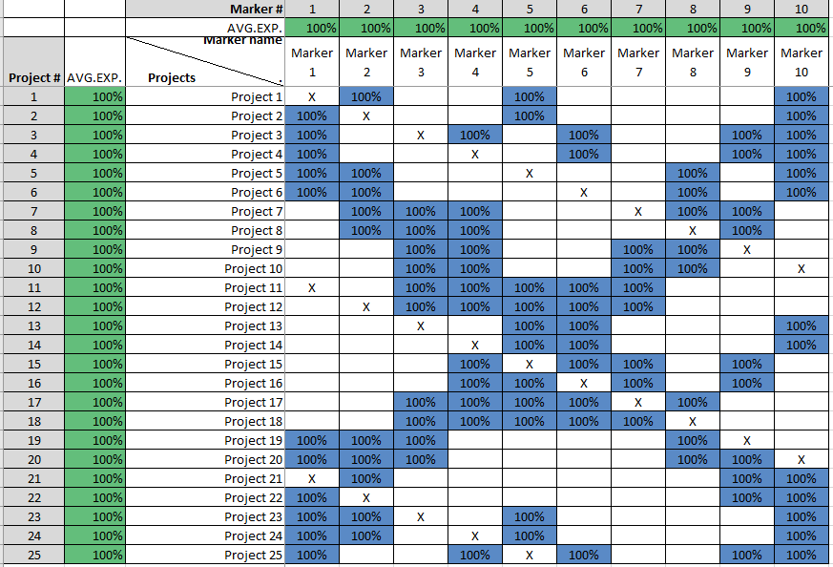

Figure : Project X Marker Table for a Clustered Competition

Using CoSeT for clustered competitions is described further in Appendix D.

## Normalized Scoring

As discussed in the [accompanying concepts document](https://github.com/Bert610/CoSeT/raw/main/Concepts%20and%20Best%20Practices%20in%20Competitive%20Selection%20Processes.pdf), some experts tend to score higher (or lower) than others. To reduce this tendency’s influence on the final scoring, CoSeT supports normalization of scores. Statistically, if normalization is effective it should reduce the variance in the scores for projects (and also change the ranking of some projects). Normalization become less relevant when each marker does not receive a statistically comparable sample of the submissions to the competition[17].

The basic normalization approach is to calculate the total of the scores provided by an expert and scale their individual scores so that the average of each expert’s scores is the same.

CoSeT’s Results sheet shows the raw scores, the Normalization Factor calculated for each marker, the Normalized scores, and finally the Project scores. The Analysis sheet compiles statistics for each marker of a submission (min, max, span, variance, and standard deviation), both for the normalized and raw scores. The Analysis Chart provides a visual presentation of these parameters. This enables the competition organizers to understand the numerical quality of the markers’ scores, and whether normalization improves (i.e., reduces) the scoring variance.

The competition organizers can turn on or off normalization once the scores have been collected. This allows competition organizers to decide whether to apply normalization once they see its impact on the data[18].

## Data Management

The combination of Submissions, Markers, Criteria and Keywords can lead to a significant amount of information that needs to be managed. When considering assignments for a competition with 25 submissions and 10 markers there are 250 possible submission/marker combinations. Given the number of submissions, and number of markers required to mark each submission, the required number of experts can be calculated:

*# of markers = #of submissions X #of markers per submission / #of assignments per marker*

If each submission has four evaluations that means 100 evaluations. If personalized files are to be shared with markers, this means at least four files for the evaluation of each submission. This emphasizes the need for approaches that are effective in managing large amounts of information.

To help manage this information, CoSeT structures the data in tables, and tends to hide sheets that are not relevant. Perhaps more relevantly, it encourages the organizers to store information for each phase of the competition in a separate folder and structures the file names to help clarify their role. Table 3 lists the various types of folders and files. Note that CoSeT currently can export of compiled comments as HTML, XLSX, TEXT or PRN files.

|  |  |  |
| --- | --- | --- |
| **Description** | **Suggested Folder Name** | **Filenames** |
| Requests for project expertise | /Project Expertise – as Requested | * ProjectExpertise.xlsx |
| Marker Expertise ratings on projects | /Project Expertise – as Received | * ProjectExpertise.xlsx |
| Request for keyword expertise | /Keyword Expertise – as Requested | * KeywordExpertise.xlsx |
| Keyword ratings by experts | /Keyword Expertise – as Received | * KeywordExpertise.xlsx |
| Evaluation requests assigned to markers | /Marks – as Requested | * Marks.xlsx  * MarksWcmts.xlsx |
| Marker evaluations received | /Marks – as Received | * Marks.xlsx  * MarksWcmts.xlsx |
| Compiled Comments | /Comments | Depends on the type of file created |

Table CoSeT files and folders

CoSeT is driven from the data entered in the Project, Marker, Keyword and sheets, and the subsequent information gathered from markers.

## Workflows Enabled by CoSeT

As discussed above, CoSeT can be used with a variety of selection competition approaches:

|  |  |
| --- | --- |
| **Aspect** | **Approaches** |
| Information sharing | via online sheets or personalized files |
| Expertise | via keywords, marker ratings, or staff ratings |
| Assignments | fully automated or a combination of manual and automated |
| Scoring | with or without normalization, with or without comments from the markers |

Table : Options in Competition Approaches

Two workflows are described below for the same hypothetical competition to help understand how CoSeT supports competitive selection processes. Three criteria are used, each with possible scores from 1 to 5. The data set has: 25 submissions (proposed projects), and 10 experts scoring the submissions.

Consistent with many experts, these artificial expertise ratings are strongly biased towards 1) not declaring any expertise (blank), and 2) declaring low expertise. This matches a commonly seen pattern where experts declare few submissions or subjects over which they feel strong expertise. In this competition, markers also participate as mentors to competitors (see the Projects table).

Two workflows are described:

1. Information shared via online sheets with expertise gathered via experts’ confidence ratings on each project.
2. Information shared via personalized worksheets with expertise gathered via keyword confidence ratings.

### Workflow #1: Online Worksheets and Expertise Gathered via Project Expertise

1. The organizer opens CoSeT and selects  from the Macros sheet. This will present the Projects, Markers, Criteria, Keywords and Competition Parameters sheets.
2. The information on the projects received is entered in the Projects table (titles, organizations, precis). The competition organizer also specifies which marker is mentoring each submission.

|  |
| --- |
| TIP: When entering data in the Projects, Markers, Criteria, and Keywords sheets, take care not to drag cells to different locations. If you are copying lists into these sheets use Copy/Values to avoid disrupting other formulae. |

1. 10 markers are recruited. All markers are also mentors for one or more submission. Their names and organizations are entered in the Markers table, which also displays the number of submissions each marker is mentoring.
2. Three Criteria are entered, along with the minimum and maximum scores possible.
3. The organizer reviews and update the Competition Parameters, particularly the number of evaluations for each submission, and the limit on the number of submissions each marker will evaluate[19]. It is decided that each marker will be asked to score 10 submissions, and each submission will be evaluated by 4 markers.
4. The organizer presses the  on the Macros sheet to create an XLSX file with the data for this competition and saves the file to a convenient location.
5. Since the markers will be asked to indicate their expertise by project, the organizer copies the Projects X Markers table, and uses it to make an online sheet for markers to enter their expertise for each project.
6. Each marker is then asked to indicate their expertise level for each project (H, M or L) and indicate conflicts of interest with an X.
7. The competition organizer reviews the online Projects X Markers table for completeness and accuracy (with regards to known conflicts of interest).
8. The organizer copies the Projects X Markers table back into the Project X Marker sheet, ensuring its layout (rows and columns) matches the sheet in CoSeT.

|  |
| --- |
| TIP: After manually editing the assignments, remember to run propogate the final assignments to the Results and Analysis sheets. |

1. The organizer selects  from the Macros sheet, & reviews the assignments generated, either on the Assignments Master sheet or the Expertise Crosswalk sheet. If the organizers wish to change assignments, they manually edit the marker numbers of those assigned to a project in the Expertise Crosswalk sheet.
2. The organizer copies the raw scoring table from the Results Scoresheet to the online sheet for markers to enter their scores.
3. The markers enter their scores in the online sheet.
4. The competition organizer copies the scores from the online sheet back into the Results scoresheet’s Raw Scores table.

|  |
| --- |
| TIP: To toggle normalization on and off, change the TRUE / FALSE cell in the top row of the Normalization cell on the Results sheet. The Analysis sheet shows both the normalized and raw scores in the same table. |

1. To see the highest ranked submissions, they sort the results table by decreasing score (and remember to save the completed competition workbook 😊).
2. To propagate the scores in the Results sheet to the Analysis sheet the organizer runs the macro.
3. They review the scatter in the scoring on the Analysis Chart, both with and without normalization, and finalize the list of ranked scores on the Results sheet.

### Workflow #2: Personalized Worksheets and Expertise Gathered via Keyword Ratings

1. The organizer opens CoSeT and selects  from the Macros sheet. This will present the Projects, Markers, Criteria, Keywords and Competition Parameters sheets.

|  |
| --- |
| The Projects, Markers, Criteria and Keywords sheets calculate the number of projects, markers, criteria and keywords based on the Name column of those sheets. These counts are displayed at the top of the sheet, to the right of the data entry table. |

1. 25 submissions are ‘received’. This information (title, precis, organization) is entered in the Projects table.
2. 10 markers are recruited, also from Canadian colleges. The markers may also be mentors to one or more submission. Enter this information in the Projects table (the marker number for the mentor for each project).
3. The organizers look over the submissions’ information[20] and decide that 11 (equally weighted) keywords describe the expertise themes for the competition. These are entered in the Keywords table along with their weights.
4. The organizer enters the selection criteria on the Criteria sheet, indicating the minimum and maximum score for each criterion.

|  |
| --- |
| TIP: the small secondary table on the Competition Parameters sheet calculates the number of marking assignments and the number of marking assignments per marker given the parameters. You should override them on the main table of the Competition Parameters sheet, allowing you to  keep a reference to the nominal values. |

1. The organizer defines the parameters for this competition (Competition Parameters sheet). In this competition three criteria are used, each with possible scores from 1 to 5. The organizers need to decide how many markers should evaluate each submission. They decide each submission is to be scored by 4 experts, which means 100 marking assignments are required (25 submissions x 4 evaluations each). With 10 experts, that means each expert will rate 10 submissions. Since scores and comments will be requested from the markers, the entry in the Competition Parameters sheet for this is set to TRUE (i.e., both score AND comments will be requested). They specify that the compiled comments should be saved as TEXT files.
2. They press  to create an Excel .XLSX file with the sheets sized for the number of projects, markers, keywords and criteria in this competition[21].
3. The organizer selects  on the Macros sheet and select a directory for the personalized keyword information files. These files name have the following pattern: *Marker# Marker_Name* KeywordExpertise.xlsx (e.g., “4 Abdelaziz Morad KeywordExpertise.xlsx”)
4. The organizer then shares these files with the markers (perhaps via an email merge or a secure website, e.g., SharePoint). The markers edit their files to show their level of confidence on the keywords and whether they are in conflict of interest with any of the submissions. They return the files to the organizers. The organizers store the completed keyword expertise files in a folder separate from the blank keyword expertise sheets.
5. To load the expertise into CoSeT, the competition organizer presses  on the Macros sheet, and selects the folder containing the completed keyword expertise files. The markers’ self-assessed expertise with regards to the keywords is loaded into the Keyword Expertise sheet and any declared conflicts of interest are loaded into the Projects X Markers table. The compiled keyword expertise gives an initial sense of the expertise in the group of markers. The organizer reviews the Keyword Expertise table for any gaps signaling the need to recruit additional markers.

|  |
| --- |
| TIP: If you fill out the Project Keyword table before loading the Keyword expertise, CoSeT will continue to populate the Project X Marker sheet automatically. |

1. The competition organizer then rates the importance of each keyword topic (Low, Medium, High) and store this in the Project Expertise sheet.
2. To create the table of Projects X Markers expertise, the competition organizer selects , which creates the Project X Marker table from the Project Keyword, and the Marker Expertise sheet (see Figure 11 below). The organizers then review the anticipated set of markers’ expertise for the submissions. If necessary, they revise their expert recruitment.

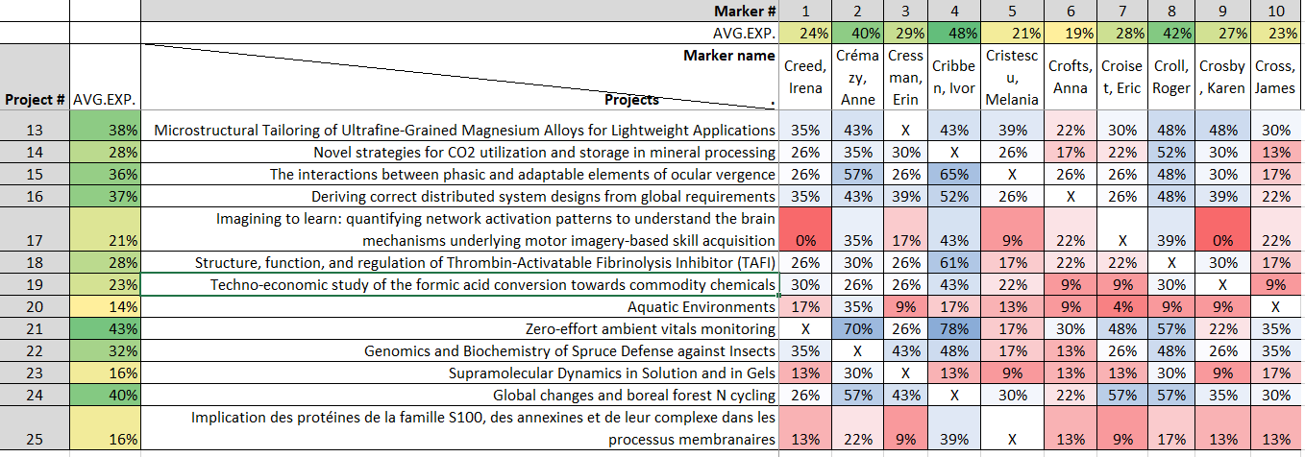

Figure : Project X Marker Table Created using Keyword Information

1. Satisfied with the available expertise, the organizer selects  from the Macros sheet. They then review the assignments, either on the Assignments Master sheet or the Expertise Crosswalk sheet. If they wish to change assignments, they manually edit the marker numbers of those assigned to a project in the Assignments Master sheet.

|  |
| --- |
| Making scoring workbooks is perhaps the slowest macro in CoSeT. It may take 10 or 20 seconds to create each scoring workbook. |

1. They select  from the Macros sheet and specify the folder to store the personalized files for the markers to enter scores and comments for each submission they evaluate. These files have the pattern: *Marker# Marker-Name* MarksWcmts.xlsx. In each file is an instruction sheet, followed by a single sheet for each submission to be evaluated.
2. The organizers share these files with the markers. For each project they been assigned, the markers:
   1. Confirm that they are not in conflict for the submission.
   2. Rate their confidence in evaluating the submission (now that they have seen the submission).
   3. Provide a general comment about the submission.
   4. Score each criterion.
   5. Provide a comment for the submission in each criterion.

An extract from a marking sheet is provided below.

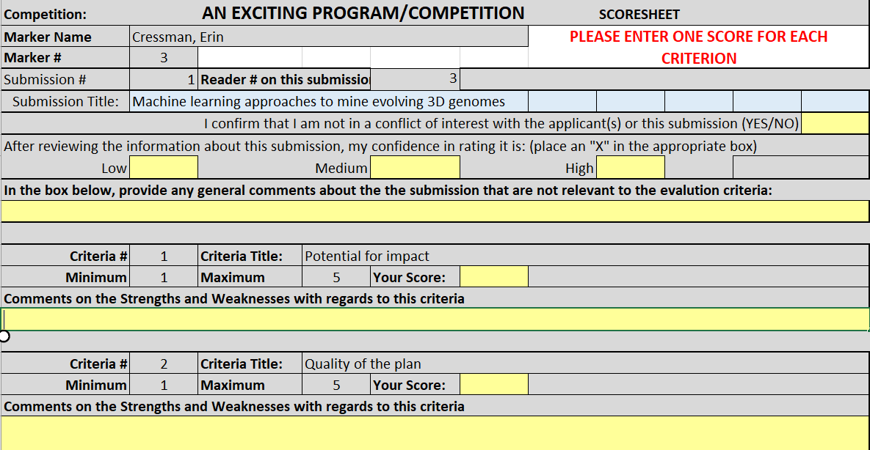

Figure : Example Scores and Comments Sheet

1. The markers return their file to the organizer. The organizer stores the completed marker scoresheets in a folder (different from the blank scoring workbooks).
2. To load the expertise into CoSeT, the competition organizer presses on the Macros sheet. The macro asks the organizer to select the folder containing the completed scoresheet files. The scoring and comments workbooks are then opened, and the scores are information loaded into the Results sheet. The combined scores are propagated to the Analysis sheet, and the Analysis chart.
   1. The Results sheet includes formulae that process the scores to calculate normalized scores and compiles a ranked list of projects by decreasing score.
   2. The Analysis sheet provides scores organized by reader (for each project), as well as statistics about the competition.
   3. The Analysis Chart showing some general trends for the competition including the variance for the project scores.

The competition organizers review the competition results and confirm whether they want to apply normalization to the scores. Many competitions have a limited budget to award, or a limited number of awards available. In this context the variance in the cutoff-zone between the successful and unsuccessful submissions is of particular interest. Once satisfied with the ranked list of submissions, they save the completed competition workbook.

The  also compiles the comments from all the markers into separate .TXT files for each submission. Since comments from markers typically vary in language quality and tone, the competition organizers will want to edit the comments before sharing them with the applicants.

## The Macros

As noted in this document, CoSeT uses macros[22] to process the information provided. These macros are accessed via buttons on the Macros sheet. CoSeT includes macros to:

* Clear the Projects, Markers, Criteria, and Keywords table, in anticipation of starting a new competition.
* Create a competition workbook with sheets customized for the data entered for a set of projects, markers, criteria, keywords and competition parameters.
* Generate worksheets where each expert can indicate their expertise.
* Compile the expertise worksheets into a single table.
* Combine the project and expertise information into a single table.
* Assign experts to evaluate submissions.
* Generate worksheets for each expert to score their assigned submissions or generate a sheet for the online shared scoring sheet.
* Compile the experts’ scores to create the Results (not needed for online sheets).
* Propagate scores from the Results sheet to the Analysis sheet and chart (needed for online sheets).

Below is an image of CoSeT’s macro workflow as seen on the Macros sheet:

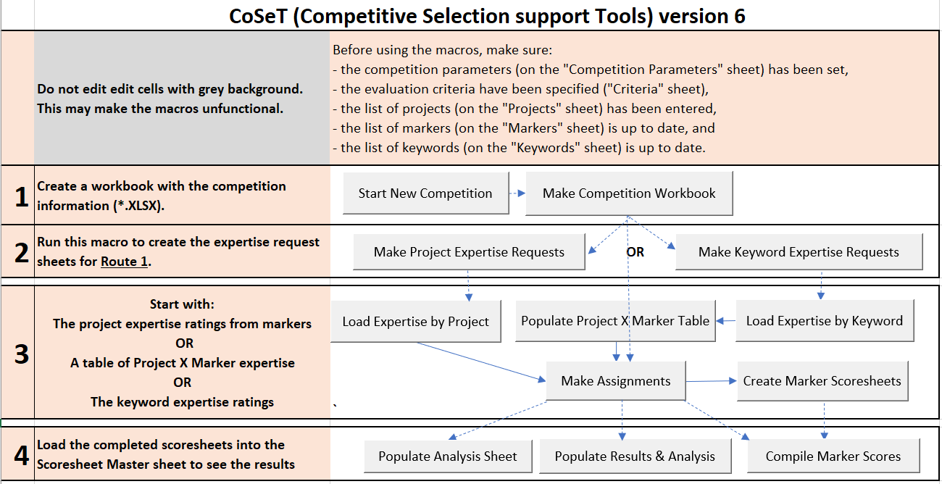

Figure : CoSeT’s Macro Workflow

The arrows give a sense of the possible workflows. The macros are generally transactional – they take information from one or more Excel sheets and move it to another sheet, sometimes transforming the information (i.e., when creating the expertise ratings in the Project X Marker table, and when normalized scoring). Parameters related to the implementation of CoSeT are defined in the System Parameters sheet[23], while parameters related to the current competition can be set in Competition Parameters sheet[24]. The macros are listed in the table below.

|  |  |  |
| --- | --- | --- |
| **Button** | **Action** | **Tables involved** |
|  | Shows the sheets that need input to start the competition workbook (blank). | Projects, Markers, Criteria and Keyword, Competition Parameters |
|  | Create the competition workbook | Most sheets … |
|  | Generate personalized workbooks for experts to indicate their confidence based on information about each submission (also indicate conflicts of interest) | Projects, Expertise by Project – Template, Expertise by Projects – Instr. |
|  | Generate personalized workbooks for experts to indicate their confidence in marking based on keywords (also indicate conflicts of interest) | Keywords, Expertise by Keyword – Template, Expertise by Keywords – Instr. |
|  | Load personalized project expertise sheets into the project X marker table, along with any conflicts of interests specified. | Personalized project expertise workbooks, Project X Marker |
|  | Load personalized keyword expertise sheets into the Keywords Expertise sheet. Also loads conflict of information info into the project X marker table | Personalized keyword expertise workbooks, Keywords Expertise, Project X Marker. |
|  | Create the project X marker table from the Project Expertise, Keyword Expertise and project X marker (for COI) info, the output stored in the project x marker table. Used with online collection of marker expertise. | Project Keywords, Marker Expertise, Project X Marker |
|  | Make marker assignments given the project X marker table | Project X Marker, Assignments Master |
|  | Create personalized scoresheets for the markers to indicate their scores. | Assignment Master, Marker Scoresheet – Template |
|  | Load information from the personalized scoresheets into the master scoresheet to produce a summary of the competition | Personalized scoresheets, Results, Analysis, Analysis Chart |
|  | Ensure the Analysis sheet reflects the information in the Results sheet. Used with online scoresheets. | Assignments Master Results, Analysis, Analysis chart |
|  | Ensures the Results and Analysis sheets are updated (i.e., after manual assignment edits | Assignments Master, Results, Analysis, Analysis chart |

Table Summary of Macro Buttons

## Worksheets in CoSeT

The table below shows the sheets in CoSeT (most of which are hidden in the CoSeT workbook). The 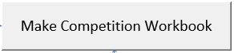 macro adapts these sheets for the competition workbook. This adaptation includes adding rows or columns for projects, markers, keywords, criteria. The macro also adds columns for the number of reader assignments planned. It also adds the project, marker, keyword and criteria information to the relevant sheets[25]. Template sheets for files sent to markers are hidden in the competition workbook. They are also customized by the  macro.

|  |  |
| --- | --- |
| **ReadMe** | **Description** |
| System Parameters | Describes limits inherent in the current implementation of CoSeT (e.g., limits on # of submissions, markers, markers-per-submission, keywords, criteria) |
| Competition Parameters | Describes parameters for the current competition (e.g., the name of the current competition, requested # of markers per submission) |
| Criteria | List of the evaluation criteria and their scoring ranges |
| Projects | Table of submission #s, submission titles, descriptions, organizations, mentors to submissions (who are markers) |
| Markers | List of experts who will score the competition, their organization, and the number of submissions they are mentoring |
| Keywords | Keywords relevant to the submissions (and their relative weights) |
| Macros | Launch page for macros |
| Project Keywords | Table that compiles how each submission relates to the keywords. If the indirect approach is used, this table is typically completed by the people supporting the competition. |
| Marker Expertise | Table showing how the markers’ expertise relates to the keywords. This can be copied from a shared sheet that the expertise is enter data into, or compiled from individual sheets sent to experts. |
| Project X Marker | Table that compiles how the expertise of the markers relates to the projects (FOM = Figure of Merit) |
| Expertise Crosswalk | Similar to the calculated FOM sheet, but also includes assignments, and the estimated confidence of the experts about the submissions they will score. |
| Assignments Master | This sheet shows the assignments by project, and statistics such as the number of assignments per marker. |
| Results | Tables for the raw scores by markers, marker normalization factors, normalized scores for markers, and rank ordered list of projects |
| Analysis | Tables with statistics for each project by reader number (raw and normalized) |
| Analysis chart | Chart with rank ordered project scores, max scores, min scores, spans, variances and standard deviations) |
| Expertise by Projects - Instructions | Instructions to the expert on how to complete the Expertise table listing all the projects (table also captures conflicts of interest). |
| Expertise by Keywords - Instructions | Instructions to the expert on how to complete the Marker Expertise sheet listing the competition keywords, and the personalized Conflicts of Interest sheet. |
| Marker Project - template | Template for experts who will rate their expertise on each submission. |
| Marker Keywords - template | Template for experts who will rate their expertise on keywords |
| Marker Scoresheet - template | Template for experts to enter submission scores. |
| Shared Scoresheet - Template | Template for the shared scoresheet that allows experts to enter their scores and combines them into a final competition results table. |
|  |  |

Table Worksheets in CoSeT

## Manual Edits

CoSeT permits a few types of manual edits. Users can edit:

* the expertise compiled about markers and projects,
* the Project X Markers table, and
* the assignments made to markers.

Editing the Project Expertise table, and/or the Keyword Expertise tables can be useful when replacing a marker or project in the competition. This can also be useful when the expertise provided by experts is insufficient for a satisfactory set of assignments (demonstrated by not all projects getting full marking assignments). After making your edits, the downstream macros (and ) need to be run to produce a new set of assignments.

If the competition is being set-up as a clustered competition *without* expertise provided by markers, the competition organizer can adjust the Keyword Expertise and Project Keywords sheet to optimize the marker assignments. Generally, this approach involves edits to the markers ‘assigned’ to a particular sub-competition cluster. See Appendix D for further discussion about using CoSeT for a clustered competition.

The competition organizer can adjust the assignments shown on the Assignments Master sheet. They can:

* delete assignments on the Expertise Crosswalk sheet, and then run  to see if more suitable assignments are produced.
* Replace markers by changing the numbers in the assignment columns of the Expertise Crosswalk sheet. When changing assignments, refer to the marker assignment summary provided on the Assignments Master sheet to identify which markers have room for more assignments.

Subsequently the  macro needs to be run to update those tables.

# For Further Information

CoSeT is available on [GitHub](https://github.com/Bert610/CoSeT). To learn more about CoSeT, download the release and browse the worksheets. The workbook comes with a small sample data set which can be used to explore how the sheets and macros support information processing for competition selection processes. A large data set can also be found in the release package. Once you have a sense of the worksheets, run through one of the sample workflows supported by CoSeT to build your understanding of the process[26].

Review the Readme on [Github](https://github.com/Bert610/CoSeT) for features & bugs associated with the current version of CoSeT. As an open-source tool, CoSeT is provided as is, without warranty.

You can reach the author at [bvmm@ncf.ca](mailto:bvmm@ncf.ca)

# Appendix A: Tables and Documents Created by CoSeT

The following tables lists the tables created by CoSeT. They are created by the ‘Create Competition Workbook’ macro, and then filled with data/results as information is gathered for the competition.

|  |  |  |
| --- | --- | --- |
| **Sheet/Document name** | **Description** | **Comment** |
| **Working documents in the Competition Workbook** | | |
| Project Keywords | Table of Projects X Keyword expertise in L (low), M (medium) and H (high). Also the same table but with numerical confidence levels | Compiled from personalized sheets sent to markers, copied from online sheet, or created by competition staff |
| Marker Expertise | Table of Marker X Keyword expertise in L (low), M (medium) and H (high). Also the same table but with numerical confidence levels | Compiled from personalized sheets sent to markers, copied from online sheet, or created by competition staff |
| Project X Marker table | Table of Project X Marker expertise and exclusions. Also includes average expertise levels for Projects and Markers | Created by combining Project Keywords and Marker Expertise tables, or directly from online sheets, or directly entered by competition staff |
| Expertise Crosswalk | Multiple information for assignments on projects: expertise levels, assigned marker confidence, marker numbers assigned, and Marker X Project table | Filled in by Assign Markers macro, using the information in the Project X Marker table, as well as exclusions provided in the Projects and Marker Expertise sheet. Exclusions provided by staff before running Assign Markers macro are adopted. |
| Assignments Master | Three tables:  - Definitive table of marking assignments.  - Assignment statistics by Marker  - Summary assignment statistics | Filled in by Assign Markers macro. |
| Results | Four tables, moving from raw data to final competition ranked list:  - raw scores by marker and project  - marker normalization factors  - normalized scores by marker and project  - scores by project | When using scoresheets, the Compile Marker Scoresheets loads scores into the raw table. When using online sheets, the scoring results need to be copied into the raw-scores table. |
| Analysis | One large table with raw and the normalized data providing quantitative data for analysis of the competition results. The tables provide scores for each reader on a project, average scores, min, max, span and variance, and standard deviation. | The tables are loaded from the same data in the Results sheet by the Populate Analysis Sheet macro. |
| Analysis chart | One chart with traces for the projects rank ordered by score. | The chart is generated by the Populate Analysis Sheet macro. |
| **Documents exported and to be shared with markers (based on CoSeT templates)** | | |
| Keyword Expertise | A file with three sheets: Instructions, a list of keywords to rate, and a list of projects to declare conflicts of interest against. | Generated by the “Make Keyword Expertise Requests” macro. Completed sheets are loaded into CoSeT by the “Load Expertise by Keyword” macro, completing the Marker Expertise table, and creating the Project X Marker table if the Project Keywords table is already complete. |
| Project Expertise | A single sheet list of projects for the markers to signal their expertise and conflict of interest | Generated by the “Make Project Expertise Requests” macro. Completed sheets are loaded into CoSeT by the “Load Expertise by Project” macro, creating the Project X Marker table. |
| Scores | A single sheet with rows for each project assigned, and columns for each criterion to score. | Created by the “Create Marker Scoresheets” macro. |
| Scores & Comments | A workbook with a cover comments sheet with links to the subsequent sheets for providing scores and comments for each project | Created by the “Create Marker Scoresheets” macro. |
| **Documents exported from CoSeT for the Competition Organizers** | | |
| Comments | Text export of comments provided by markers. One sheet per project, with comments organized by criteria. A variety of export formats are possible. | These comment documents should be edited before sharing with the applicants. |

As noted above, the  macro adapts these sheets for the competition workbook. This adaptation includes adding rows or columns for projects, markers, keywords, criteria. The macro also adds columns for the number of reader assignments planned. It also adds the project, marker, keyword and criteria information to the relevant sheets[27]. Template sheets in the competition workbook are generally hidden.

# Appendix B: System Parameters Sheet

The System Parameters sheet defines some items for CoSeT most competition organizers will not change. This includes:

* *The password used to lock documents shared with markers.* Note that users of CoSeT do not need to unlock any sheets during regular use – the cells they typically edit are unlocked[28]. The macros load information from the files shared with markers into the competition workbook.
* *File naming patterns for files shared with markers.* The potential files include:

|  |  |
| --- | --- |
| **File description** | **File naming pattern** |
| Form for markers to describe their confidence to marker each submission, and signal any conflicts of interest | * ProjectExpertise.xlsx |
| Form for marker to describe their expertise relative to keywords for the competition, and also signal any conflicts of interest on the projects | * KeywordExpertise.xlsx |
| Single page form with scores for each of the projects assigned to a marker | * Marks.xlsx |
| Multipage file with sheets for each project assigned to a marker | * MarksWcmts.xlsx |

* *A flag that tells CoSeT to simulate responses from markers* (this is useful in the development of CoSeT and also for demonstrating CoSeT). It should be set to FALSE for normal use.

CoSeT reads parameters from the System Parameters sheet in the CoSeT workbook each time a macro is run. This sheet is generally hidden.

# Appendix C: Competition Parameters Sheet

The Competition Parameters sheet provides an opportunity for the competition organizer to configure parameters that adapt CoSeT’s operation in their competition. This includes parameters that should be reviewed and (generally) revised before creating the competition workbook. The sheet’s parameters include several parameters that are used to generate the competition workbook. The Competition Parameters sheet is copied into the competition workbook.

**If any of the following parameters need to be revised, then a new competition workbook must be created**:

* *Number of marking criteria in this competition*: This parameter is set from the data entered on the Criteria sheet, but is presented on this sheet as it is relevant to the competition design.
* *Desired number of markers to evaluate each submission*: The competition organizers set this parameter on this sheet. It has a significant influence on the number of markers needed.
* *Maximum number of submissions to be assigned to a marker*: The competition organizers can review the anticipated number calculated by CoSeT and over-ride it on this sheet if necessary.
* *Number of keywords*: This parameter is set from the data entered on the Keywords sheet but is presented on the Competition Parameters sheet as it is relevant to the competition design.
* *Number of Projects*: This parameter is set from the data entered on the Projects sheet but is presented on the Competition Parameters sheet as it is relevant to the competition design.
* *Number of Markers*: This parameter is set from the data entered on the Markers sheet but is presented on the Competition Parameters sheet as it is relevant to the competition design.

Cells on sheets in CoSeT that are intended for the competition organizer to modify generally have a white background. Cells that the competition organizer should not modify generally have a grey or coloured background.

The Competition Parameters sheet also includes other parameters that control how CoSeT functions. These can be changed after the competition workbook has been created.

* *Target scores after normalization* (as a percent of the ‘perfect score’ possible): While markers tend to use the top half of scoring scales, a lower scoring target may help differentiate between strong and weak proposals.
* *Name of the competition*: This text is used for introductory comments in files to be shared with markers.
* Competition Contact person & email: The intent is that this contact information is included sheets shared with markers. It is not currently used.
* *Contact Website:* This information is intended for inclusion on sheets shared with markers.
* *Root Directory for this Competition:* This should be the path for the folder that holds the competition workbook, and subfolders for the various files to be managed. This includes:
  + expertise by project requested folder
  + expertise by project received folder
  + expertise by keyword requested folder
  + expertise by keyword received folder
  + scores requested folder
  + scores received folder
  + Comments compiled-by-project folder
* *Use the organization to personalize file names (TRUE/FALSE):* When TRUE, CoSeT will include a version of the marker’s name in file names to share with the marker (for disambiguation).
* *Use Email in Personalized File Names (TRUE/FALSE):* When TRUE, CoSeT will include a version of the marker’s email in file names to share with the marker (for disambiguation).
* *Use Normalized Scoring (TRUE/FALSE)*
* *Gather Comments on the Submissions (TRUE/FALSE):* 
  + If TRUE a multi-sheet file is created for each marker that includes space for comments. CoSeT will extract both the scores and comments from these files. The scores are loaded into the Results sheet, and the comments are separately compiled into separate documents for each project.
  + If FALSE, then a single sheet is created for each marker to provide their scores on the assigned projects. CoSeT extracts the scores from these sheets and loads them into the Results sheet.
* *Comment Output format:* Current choices are Choices: HTML, XLSX, TEXT or PRINTER. TEXT is a reasonable format for getting the comments into a word-processing application for further editing.
* *Treat blank expertise as exclusions (TRUE/FALSE):* 
  + If TRUE, markers will not be assigned to any projects unless they have specifically indicated some level (Low, Medium or High) expertise. In, general, experts are reluctant to signal expertise outside their fairly narrow specialties.
  + Setting this flag to FALSE means that experts can be considered for assignment to submissions, even if they have not declared an expertise. This addresses the need to have all submissions evaluated in a context where insufficient expertise has been declared. An alternative approach would be to recruit more markers, or reduce the number of evaluations for each submission.

CoSeT reads this sheet each time it runs a macro.

# Appendix D: Using CoSeT for Clustered Competitions

In some cases, the competition may include a variety of submissions that are differentiated by topic or field. In this case, the experts may also be associated with one of these topics/fields, or the competition organizers want to cluster the markers’ assignments with one or a few topics/fields.

This clustering of markers and projects can be implemented by taking a structured approach to the Project Keywords and Marker Expertise tables.

The general approach is to:

* Define a unique set of keywords for each topic/field[29].
* Specify expertise for each project only on keywords for topic/field it is associated with.
* Specify each expertise for each marker only on the keywords for the topic/field to which they have been assigned, assigning enough markers to ensure the submissions for each topic/field are sufficient.
* Adjusting the marker keyword expertise to provide a suitable set of assignments.

The figure below shows a portion of the Project Keyword table, and the Marker Expertise table for an example clustered competition (with only one keyword per topic/field).

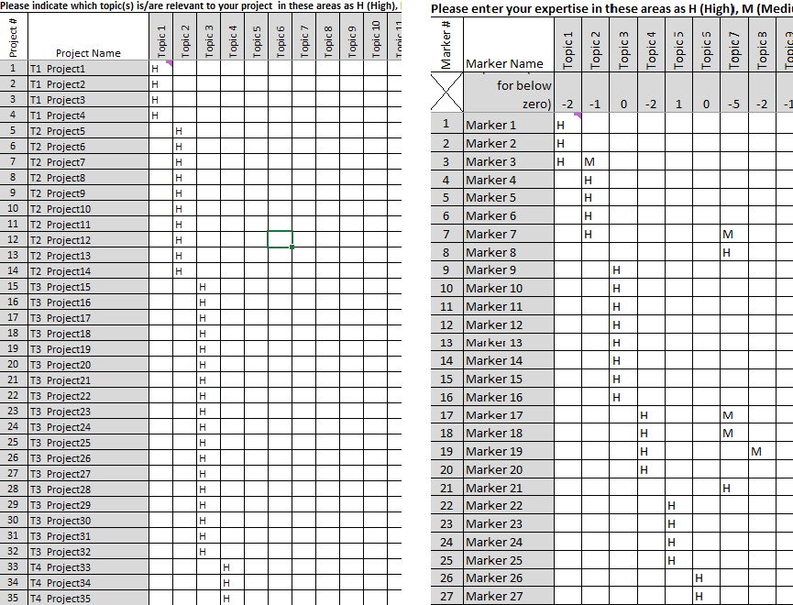

Figure : Project and Marker Tables for Clustered Competition

The observant reader will not that some markers have expertise specified in more than one topic. This is to accommodate the reality that the number of marking assignments on a topic is usually equally divisible by the marking assignments per marker. This is addressed by setting the marker’s expertise as High (H) for their main topic, and Medium (M) for a secondary topic(s). The resulting distribution of expertise shows clear clustering, with High expertise in dark blue, and Medium expertise in light blue.

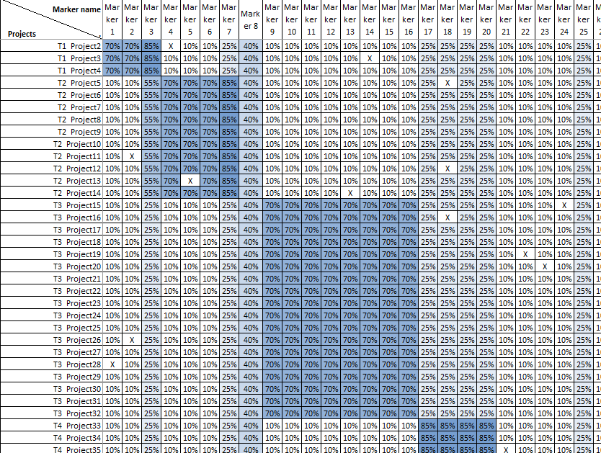

Figure : Project X Marker Table for Clustered Expertise

Below is a more detailed description of the process to realize the clustered competition expertise distribution[30].

1. Sort the submissions by topic and put a topic identifier (i.e., T*nn*) in front of the submission names (where *nn* is the topic number).
2. In the Competition Parameter sheet, it is recommended that you set the flag '**Treat blank expertise as exclusions**' to FALSE.
3. Each possible submission is assigned to a topic area in the Project Keywords sheet by placing an 'H' in the left table for the topic it has been assigned to. (in more general usage, there would be multiple keywords associated with each competition topic. For simplicity the example used here has only a single keyword for each topic – namely the topic).
4. On the Marker Expertise sheet, the topics are each assigned enough H's to make the formulas in the third row 0 or -1.

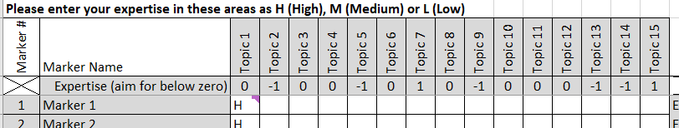

Figure : Part of Marker Expertise Table showing net Expertise row

This provides a good first estimate of the numbers needed. Then run the macro followed by .

1. 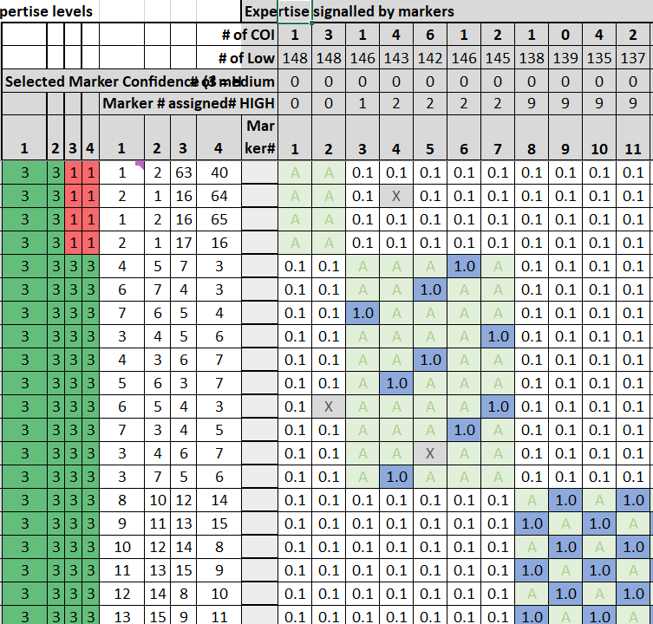This produces a first approximation of the required expertise distribution. However, the Expertise Crosswalk table will likely show that the projects for some topics have insufficient, or low expertise markers assigned (Red confidence for assignments). In terms of the desired clustering of markers to topics, this means that some markers have been assigned to projects where they were not signaled as H or M. To improve the clustering, typically two levels of refinement are needed (adding H’s and M’s).
2. For each refinement cycle, note one or two areas:
   1. Where markers are needed (Expertise Crosswalk: red cells in columns J to M)
   2. where markers with signaled expertise are not being assigned to projects. In the Expertise Crosswalk table this is shown as dark blue columns in the Project X Marker expertise table, and
   3. which markers need more assignments (Assignments Master: column Q cells with lower numbers and more intense colour).
   4. Write down the changes to make.

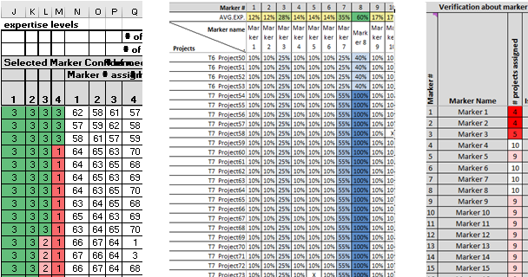

Figure : Example showing Need for Markers (Expertise Crosswalk) and Marker Availability (Expertise Crosswalk and Assignments Master)

1. On the Expertise Crosswalk sheet, delete the assignments (i.e., clear the cells in red or pink) that will be assigned to new markers.
2. Adjust the Marker Expertise table, first for cases where a topic lacks many ‘High’ expertise assignments (i.e., near or above the number of assignments per marker). Do this by deleting an H for a marker from a topic for which they see few assignments and adding an H for the marker on a topic that needs more expertise.
3. Run the macro followed by  to see how the assignments have changed.
4. Rinse and repeat (steps 6 through 9) until the groups of red cells are each less than half of a marker’s assignment complement (each marker has a complement of 10 assignments in this example).
5. If a topic area has red cells in the last assignment column that represent approximately half of a marker’s load, then conduct the edit cycle adding an 'M' for each of these required half-loads (using markers where the Assignments Master show that they need more assignments).
6. If the parameters for assignments per marker are set to provide coverage, you should be able to get to an assignment grid with few or no red cells, and only a few pink cells.

When you are first learning to do this, it is suggested that you change only a couple of entries in the Marker Expertise table for each edit cycle run (to understand what was changing).

1. Submissions can also be called applications, proposals, projects or candidates (internally CoSeT uses the term Project).
2. In this document, experts are also called markers (the latter term is used internally by CoSeT). The are also called reviewers, and evaluators, and sometimes members (when the review is conducted by committee).
3. Specifically, this includes the Project Expertise sheet, the Keyword Expertise sheet, the Results sheet, the Scores and Comments workbook, and the Results sheet’s raw scores table.
4. Experts are notoriously cautious about signaling high expertise in selection competitions. This often leads to experts being asked to evaluate submissions that they do not feel qualified to evaluate. In reality, the experts may lack some expertise for some submissions, but are still able to provide useful evaluations notwithstanding. CoSeT has a TRUE/FALSE flag that allows blank expertise responses to be treated as ‘Low’ expertise ratings.
5. This sheet (Project X Marker table) is created from the expertise and exclusion information available.
6. Each assignment round corresponds to a reader number. Thus, the first round assigns the first readers, the second round assigns the second readers (etc.). The marking algorithm results in first readers assignments (generally) that are at least as expert in their evaluation of that submission as the second readers (etc.).
7. In addition to the information for CoSeT that needs to be shared, there is also the actual submissions, as well as a variety of coordinating information about the competition.
8. Comments can also be collected with the scores, and compiled as described in the following section.
9. The data in the figure provides is for randomly generated scores. Typically, scores from experts have less, but still significant variation, with the highest and lowest scores submissions have less variation than those in the middle.
10. The arbitrary scale used for rating expertise is Low (≤33%), Medium (up to 66%), or High (up to 100%).
11. Keyword is a general term. Other ways of considering classification of expertise include themes, topics and disciplines. Ideally a non-overlapping set of keywords can be created for the competition.
12. I.e., the dot product of Project expertise row ‘i’ and Marker Expertise row ‘j’.
13. The data was randomly created for experts signaling High expertise 5% of the time, Medium expertise 15% of the time, and Low expertise 80% of the time. “X” indicates that the marker should be excluded from marking this project (from entries for ‘mentor’ roles provided on the Projects sheet.
14. Other competition parameters include: how many points are used for each criteria, and is there a language ladder for scoring. Competitions that use committee evaluations may give special roles to a marker, often described as the ‘first-reader’, giving them more influence on final scores for a submission.
15. This is the case in some calls-for-proposal with subtopics specified, or in large general programs like NSERC Discovery Grants program.
16. If a competition has multiple groups of submissions, each with their own awards/prizes, a separate competition workbook is typically created for each group of submissions.
17. See <https://www.surveysystem.com/sscalc.htm> for an online sample size calculator and a brief discussion of the concept.
18. The normalization flag is also accessible on the Results sheet (top row).
19. In reality, setting the competition parameters is often iterative. The organizers typically estimate the number of submissions expected and start recruiting experts. The parameters get updated once the final number of submissions and experts is known. The competition workbook can be created once an upper bound on the number of submissions, markers, criteria and keywords has been established.
20. In some competitions the applicants need to submit an intent-to-apply notice before the submission. This lets the organizers anticipate approximately how many markers are needed, and what domains of expertise should be addressed by the markers.
21. CoSeT will prompt the user to specify the competition workbook if it is not currently open in Excel.
22. The macros are written in Visual Basic for Applications (VBA).
23. See Appendix B for a description of the System Parameters sheet.
24. See Appendix C for a description of the Competition Parameters sheet.
25. These modifications mean that the layout of sheets in the competition workbook generally should not be modified – it may make CoSeT misfunction.
26. Leave on the “Simulate Marker Responses” flag (System Parameters) to have CoSeT generate simulated responses from markers, which more readily lets you test the workflow steps.
27. These modifications mean that the layout of sheets in the competition workbook generally should not be modified – it may make CoSeT misfunction.
28. At present, the sheets in the CoSeT workbook, and the sheets in the competition book are not password protected.
29. In the limit there is only one keyword for each topic/field.
30. The folder **Sample 157P 72M 5C 4R 15K** in the CoSeT release contains this clustered competition example.